

**Extend SuccessFactors Employee Central with apps on SAP HANA Cloud Platform**

**Using SAP HANA Cloud Platform /Portal to Create   
SAP Corporate Benefits Sample Extension**

Table of ContentS

Welcome 1

Overview - SAP Corporate Benefits sample extension 1

Tutorial agenda 2

Prerequisites 2

Exercise 1: Setting up the Work Environment 3

Access your HANA Cloud Platform account 3

Start Eclipse 4

Verify your environment 5

Verify Eclipse proxy settings 5

Verify target runtime settings 6

Verify HANA Cloud server settings 8

Get the source code 8

Import the source code into Eclipse 9

Exercise 2: Developing AND DEPLOYING THE Corporate Benefits application 12

Architecture Overview 12

Compile the Corporate Benefits application 13

Build the project 13

Deploy the Corporate Benefits application to the HANA Cloud platform 14

Deploy the application from the console 14

Configure your application on the HANA Cloud platform 16

Configure the application role assignments 16

Configure application-to-application SSO 17

Create a Cloud Portal widget 19

Exercise 3: Creating and Integrating the COrPORATE BENEFITs Extension into SuccessFactors 20

Create the extension 20

Access the SuccessFactors environment 20

Add an Extension to your *My Favorites* list 20

Create a new extension 21

Add content to the extension 21

Set the Site and Page Access Level 22

Hide the Page from the Page Navigation Bar 22

Edit the extension URL 22

Publish the extension 23

Add an extension / application to SuccessFactors 23

Add a tile to the Home Page 24

Set up your tile 24

Add content to the tile 25

Preview and save the tile 26

Customize a theme for the tile 26

Update the extension theme 26

Creating a custom SuccessFactors theme 27

Applying the SuccessFactors theme to the Cloud Portal extension 27

Exercise 4: Explore the corporate benefits extension 28

Employee role 28

HR manager role 28

Perform HR manager tasks 28

Perform End User Tasks 30

# Welcome

Welcome to the partner hands-on workshop for SAP HANA Cloud Platform / Portal extension package for SuccessFactors. We will accompany you as you develop a Success Factor extension using the SAP HANA Cloud platform and Portal infrastructure. After you deploy the extension, you will integrate it into the SuccessFactor BizX environment. After this session, you will have the knowledge and skills to:

* Work in the Eclipse environment to develop a range of applications for deploying to the cloud
* Create and deploy an extension on HANA Cloud platform and Portal
* Publish and brand the extension
* Manage the set of user privileges according to business roles
* Understand how you can easily add extensions to the SuccessFactors BizX environment

# 

## Overview - SAP Corporate Benefits sample extension

The SAP HANA Cloud Platform extension package enables companies to quickly, and easily, adapt and integrate SuccessFactors cloud applications into their existing business processes.

SAP Corporate Benefits is a sample extension application for SuccessFactors Employee Central. The application can be used by employees to place orders in specific benefit campaigns, and by Human Relations (HR) managers to manage employee benefits and set up new benefit campaigns.

The purpose of the sample application is to highlight the advantages of the SAP HANA Cloud Platform extension package for the development and hosting of applications that extend the SuccessFactors capabilities.

The sample application relies on and integrates the following SAP HANA Cloud Platform capabilities:

* SAP HANA Cloud Platform extension package, which provides SuccessFactors connectivity on top of the standards-based OData API
* Persistency: JPA on top of the  [SAP HANA Database technology](http://www.saphana.com/welcome)
* User interface technology: SAPUI5 (sap.m) libraries
* Back-end logic implemented by using JAX-RS Services (Apache CXF and Google Gson for JSON serialization/deserialization)

**The goal of this tutorial is to create a new SuccessFactors extension, as an SAP HANA Cloud Portal site, and to consume the application as an OpenSocial widget inside it.**

## Tutorial agenda

This workshop is structured as follows:

* 1. **Setting up the Work Environment**

To begin, you will access your SAP HANA Cloud account, start the Eclipse working environment, and import the application code from GitHub into your eclipse development environment.

* 1. **Developing the Corporate Benefits extension**

In this section, you will review the application structure and code. You will compile the application, using Maven, into a WAR file, and the deploy it to your SAP HANA Cloud account.

* 1. **Creating and laying out the Corporate Benefits extension / site**

You will now create a widget from the Corporate Benefits application and add it to a new HANA Cloud Portal Site that you create. This site will eventually become your new SuccessFactors Extension.

* 1. **Exploring the Corporate Benefits extension**

Finally, you will be able to explore the finished application, running in SuccessFactors, both as an HR manager and as an end user.

## Prerequisites

* You have the following installed on your machine:
  + Chrome browser, for use in all of the exercises in this tutorial
  + Java Development Kit (JDK)
  + Apache Maven
  + Notepad++
* A single *shared* SuccessFactors environment will be available for this exercise. Therefore please be cautious about changes and follow carefully the guidelines. The environment details are as follow –
  + <https://salesdemo4.successfactors.com/login>
  + Company – SAPTECH03
  + **IT administrator** (admin) – username – admin; password – demo101
  + **HR manager** (Nancy Nash) – username – nnash; password – demo101 (userid - nnnn)
  + **End user** (Carla Grant) – Username – cgrant; password – demo101 (userid – cgrant1)
* The Cloud Portal and SuccessFactors environments are integrated; therefore, access rights are similar to those you will use for SuccessFactor as in the previous bullet

***Good luck with developing your application.***

# Exercise 1: Setting up the Work Environment

|  |  |  |  |  |  |  |  |
| --- | --- | --- | --- | --- | --- | --- | --- |
| **#** | **User ID** | **Password** | **Account Alias** | **Account ID** | | | **HANA Cloud Portal Extension URL** |
| **1** | **p1158654** | Abcd1234 | pt003 | a3854745b | | | <https://cloudptportal-a3854745b.us1.hana.ondemand.com/>portal/extensions/sfsf/index.html |
| **2** | **p1158664** | Abcd1234 | pt005 | ad137d16e | | | <https://cloudptportal-ad137d16e.us1.hana.ondemand.com/>portal/extensions/sfsf/index.html |
| **3** | **p1158667** | Abcd1234 | pt006 | a483e80d4 | | | <https://cloudptportal-a483e80d4.us1.hana.ondemand.com/>portal/extensions/sfsf/index.html |
| **4** | **p1158671** | Abcd1234 | pt007 | a3f39b042 | | | <https://cloudptportal-a3f39b042.us1.hana.ondemand.com/>portal/extensions/sfsf/index.html |
| **5** | **p1158675** | Abcd1234 | pt008 | aaf86add3 | | | <https://cloudptportal-aaf86add3.us1.hana.ondemand.com/>portal/extensions/sfsf/index.html |
| **6** | **p1158678** | Abcd1234 | pt009 | ad8819d45 | | | <https://cloudptportal-ad8819d45.us1.hana.ondemand.com/>portal/extensions/sfsf/index.html |
| **7** | **p1158682** | Abcd1234 | pt010 | a8a707622 | | | <https://cloudptportal-a8a707622.us1.hana.ondemand.com/>portal/extensions/sfsf/index.html |
| **8** | **p1158683** | Abcd1234 | pt011 | afd7746b4 | | | <https://cloudptportal-afd7746b4.us1.hana.ondemand.com/>portal/extensions/sfsf/index.html |
| **9** | **p1158687** | Abcd1234 | pt012 | a647e170e | | | <https://cloudptportal-a647e170e.us1.hana.ondemand.com/>portal/extensions/sfsf/index.html |
| **10** | **p1161645** | Abcd1234 | pt013 | a13792798 | | | <https://cloudptportal-a13792798.us1.hana.ondemand.com/>portal/extensions/sfsf/index.html |
| **11** | **p1161646** | Abcd1234 | pt014 | a8d1db23b | | | <https://cloudptportal-a8d1db23b.us1.hana.ondemand.com/>portal/extensions/sfsf/index.html |
| **12** | **p1161647** | Abcd1234 | pt015 | afa1a82ad | | | <https://cloudptportal-afa1a82ad.us1.hana.ondemand.com/>portal/extensions/sfsf/index.html |
| **13** | **p1161652** | Abcd1234 | pt016 | a6313d317 | | | <https://cloudptportal-a6313d317.us1.hana.ondemand.com/>portal/extensions/sfsf/index.html |
| **14** | **p1162168** | Abcd1234 | pt017 | a1414e381 | | | <https://cloudptportal-a1414e381.us1.hana.ondemand.com/>portal/extensions/sfsf/index.html |
| **15** | **p1162170** | Abcd1234 | pt018 | a84abfe10 | | | <https://cloudptportal-a84abfe10.us1.hana.ondemand.com/>portal/extensions/sfsf/index.html |
| **16** | **p1162171** | Abcd1234 | pt019 | af3acce86 | | | <https://cloudptportal-af3acce86.us1.hana.ondemand.com/>portal/extensions/sfsf/index.html |
| **17** | **p1162175** | Abcd1234 | pt020 | a936b4763 | | | <https://cloudptportal-a936b4763.us1.hana.ondemand.com/>portal/extensions/sfsf/index.html |
| **18** | **p1162179** | Abcd1234 | pt021 | ae46c77f5 | | | <https://cloudptportal-ae46c77f5.us1.hana.ondemand.com/>portal/extensions/sfsf/index.html |
| **19** | **p1162183** | Abcd1234 | pt022 | a7d65264f | | | <https://cloudptportal-a7d65264f.us1.hana.ondemand.com/>portal/extensions/sfsf/index.html |
| **20** | **p1162184** | Abcd1234 | pt023 | a0a6216d9 | | | <https://cloudptportal-a0a6216d9.us1.hana.ondemand.com/>portal/extensions/sfsf/index.html |
| **21** | **p1162187** | Abcd1234 | pt024 | a9406837a | | | <https://cloudptportal-a9406837a.us1.hana.ondemand.com/>portal/extensions/sfsf/index.html |
| **22** | **p1162192** | Abcd1234 | pt025 | ae301b3ec | | | <https://cloudptportal-ae301b3ec.us1.hana.ondemand.com/>portal/extensions/sfsf/index.html |
|  |  |  |  | |  |  |  |

In this exercise, you will familiarize yourself with the HANA Cloud Platform account, start the eclipse IDE, verify the HANA Cloud settings, and import the Corporate Benefits Web application source code into your Eclipse workspace.

## Access your HANA Cloud Platform account

We have created a dedicated account on the SAPA HANA Cloud Platform for each participant in this workshop. Ask the workshop instructor to provide the details of your account from the following list:

Go to <https://account.us1.hana.ondemand.com/>.

* 1. Click *Log On* and enter your User ID (from the previous table) and password (Abcd1234)
  2. On the SAP HANA Cloud Platform Cockpit screen, navigate to the *Java Applications* link on the left panel
  3. This is where you can manage the benefits application once it is deployed.

## Start Eclipse

* 1. Open the Partner Test folder on your file system [c:/pt2014/].
  2. Open the Eclipse folder and run eclipse.exe. This starts the preconfigured Eclipse that has been prepared for this event.
  3. If the *SF* workspace does not open automatically, click *File > Switch Workspace* and go to the SF workspace:

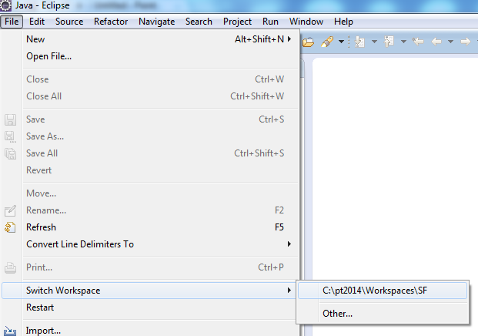

## Verify your environment

## Verify target runtime settings

* 1. In the navigation panel click *Window* > *Preferences* window
  2. Navigate to *Server* > *Runtime Environments*.

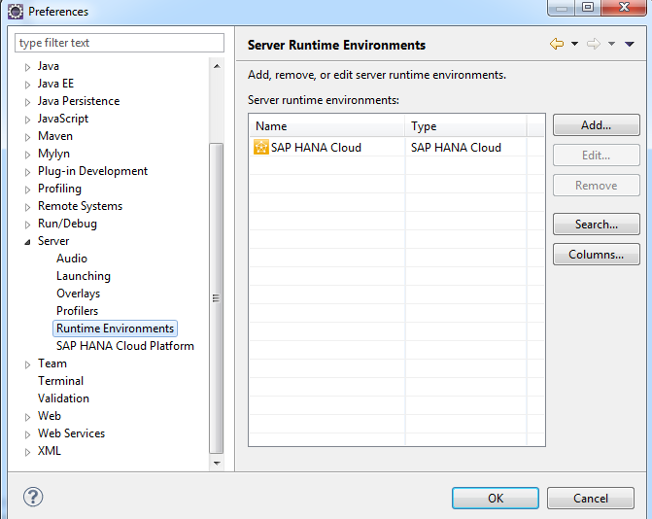

* 1. If the *SAP HANA Cloud* entry appears as shown, continue with the following section: **Verify HANA Cloud server settings**. If the entry is not displayed, click *Add*. The *New Server Runtime Environment* wizard opens.

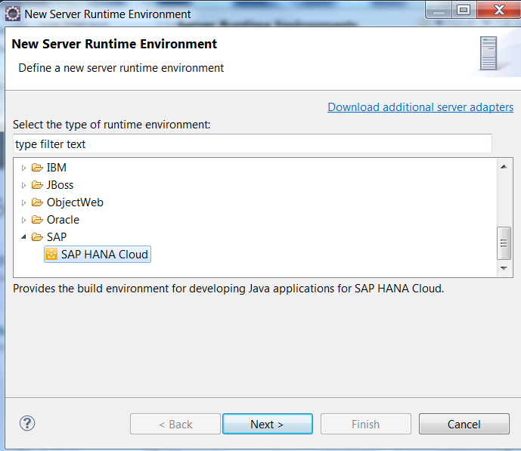

* 1. Click *SAP* > *SAP HANA Cloud*.
  2. Click *Next*.

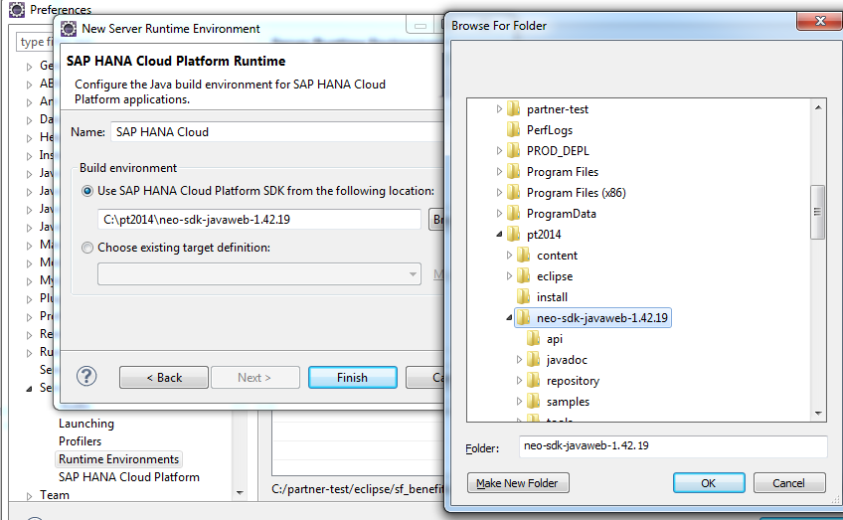

* 1. Enter the information as follows:
  + *Name*: SAP HANA Cloud
  + *Build environment*: Select *Use SAP HANA Cloud SDK.*
  + For the location, click *Browse* and go to the partner-test folder. Navigate to neo-sdk-javaweb-1.42.19
  1. Click *OK*.
  2. Click *Finish* and then *OK* to close the *New Server Runtime Environment* screen.

## Verify HANA Cloud server settings

* 1. In the navigation panel of the *Preferences* window, select *Server* *> SAP HANA Cloud*.

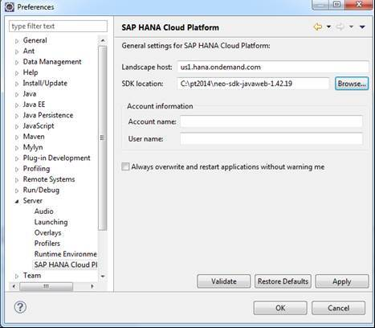

* 1. Update the following fields, as follows:
  + *Landscape host:* us1.hana.ondemand.com
  + *SDK location*: the location of the SAP HANA Cloud SDK in your partner-test folder  
    C:\pt2014\neo-sdk-javaweb-1.42.19
  1. Update the *Account information* fields, if required :
  + *Account ID:* <Your Account ID from the table above as allocated by the instructor (such as ae301b3ec)>.Use only lower case letters.
  + *User name:* <Your User ID from the table above as allocated by the instructor (such as p1162192).

For example:

|  |  |  |  |  |  |  |
| --- | --- | --- | --- | --- | --- | --- |
| **#** | **User ID** | **Password** | | **Account Alias** | **Account ID** | **CP URL** |
| **25** | **p1162192** | Abcd123 | pt025 | | ae301b3ec | <https://cloudptportal-ae301b3ec.us1.hana.ondemand.com/>portal/extensions/sfsf/index.html |

* 1. Click *Validate* and verify a positive validation result in the popup window.
  2. Click *OK*.

## Get the source code

Download the source code for the *Corporate Benefits* application from GitHub.

* 1. In your Chrome browser, navigate to <https://github.com/SAP/cloud-sfsf-benefits-ext>.
  2. Click *Download Zip* at the right and save the cloud-sfsf-benefits-ext-master.zip to the *Partner Event* folder
  3. Once downloaded, extract the zip file under your local pt2014. Make sure that you have the following folder structure (C:\pt2014\cloud-sfsf-benefits-ext).

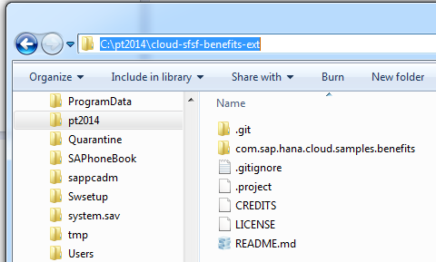

## Import the source code into Eclipse

Import the project into Eclipse.

* 1. In the *Project Explorer* tab, right-click and select *Import* > *Maven* > *Existing Maven Projects.*

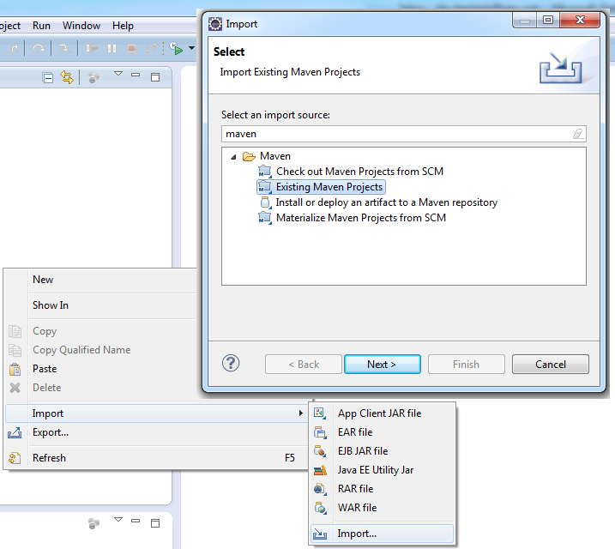

* 1. Click *Next*.
  2. In the *Root Directory* field, browse to c:\pt2014\cloud-sfsf-benefits-ext\cloud-sfsf-benefits-ext-master folder
  3. Click *OK.*
  4. Verify that *pom.xml* is selected, and click *Finish*.

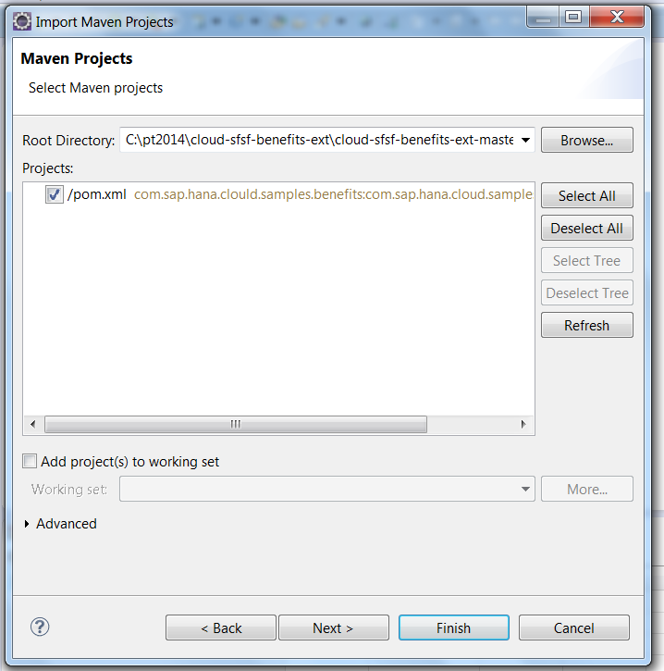

After the import, the project is available in your Eclipse Project Explorer.

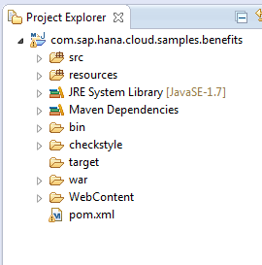

**Note:** The Corporate Benefits application is built as a Maven project. A red exclamation mark ( **!** ) displayed on the root folder of the Benefits project indicates that errors have occurred during the build process. In this case, try to update the Maven settings for the project by right-clicking the root folder of the Benefits project and clicking *Maven* > *Update project*.

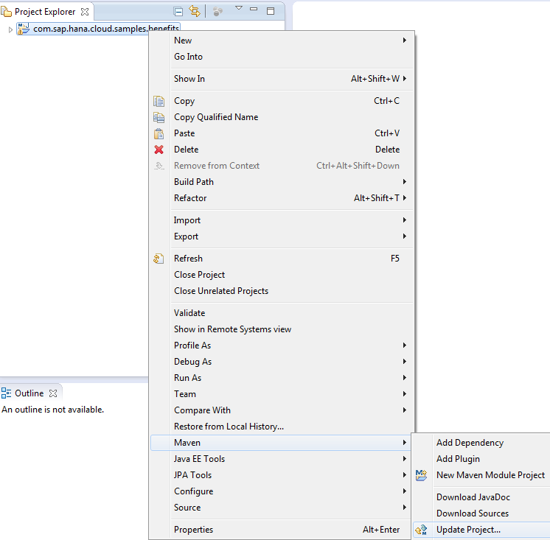

1. In the *Update Maven Project* dialog box, select the project com.sap.hana.cloud.samples.benefits checkbox and click *OK*.

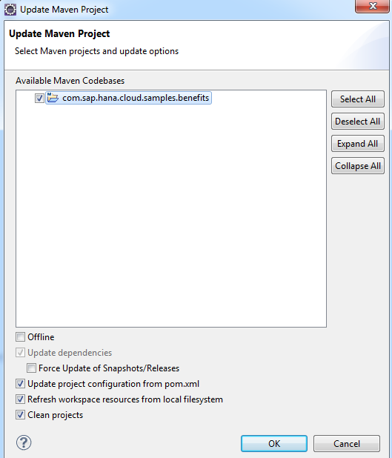

# Exercise 2: Developing AND DEPLOYING THE Corporate Benefits application

## Architecture Overview

The SAP Corporate Benefits extension application is split into two main components: back end and front end.

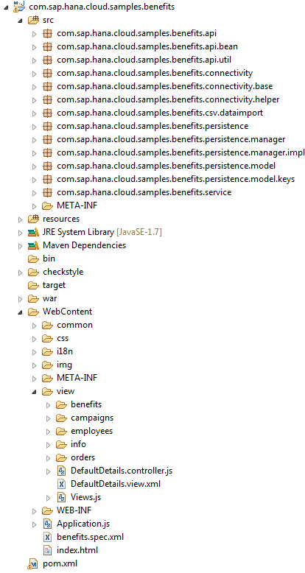

The **back end** Java sources are located under the *src* folder, organized in the following packages:

* *com.sap.hana.cloud.sample.benefits.api.*\* - REST back-end services and model for the user interface
* *com.sap.hana.cloud.sample.benefits.connectivity.*\* - OData connectivity to SuccessFactors
* *com.sap.hana.cloud.sample.benefits.persistence.*\* - Contains JPA entities and DAO objects.
* *com.sap.hana.cloud.sample.benefits.services.*\* - Web integration logic

The **front end** is located in the *WebContent* folder, and has the following structure:

* *view* - UI logic implemented using SAP UI5 XML views following the MVC pattern
* *css* - application theming
* *img* - images

**NOTE**: The application already contains the OpenSocial spec.xml file. This means that once you deploy it to the SAP HANA Cloud Platform, you can begin using the application in SAP HANA Cloud Portal by creating an OpenSocial widget for it.

The application supports two roles:

* **Administrator** - the company HR manager who administers and manages employees benefits and benefit campaigns
* **Everyone** - mapped to the regular company employees. You do not have to explicitly assign this role to users

When configuring application security, assign the appropriate role to the users accessing the application.

## Compile the Corporate Benefits application

Before you can run the Corporate Benefits application in the SAP HANA Cloud Platform Extension Package account, you must compile the project and build it into a WAR file that you can deploy to your account.

Build the project

* 1. Open a command line in the projects folder where the project’s pom.xml file is located.  
     [c:\pt2014\cloud-sfsf-benefits-ext\cloud-sfsf-benefits-ext-master\com.sap.hana.cloud.samples.benefits\ ]

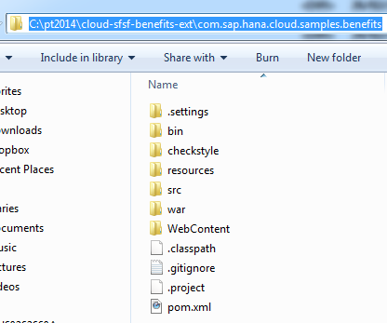

* 1. Your environments have been configured to run JDK 6, because HANA Cloud Portal currently runs this version. However The Corporate Benefits application requires JDK version 7 and up. Therefore:
     + 1. In the command line - set the JAVA_HOME environment variable to point to your local JDK -7 (>*set JAVA_HOME=C:\Program Files\Java\jdk1.7.0_21*)
       2. Now build the project: In the command line, run the command: mvn clean install

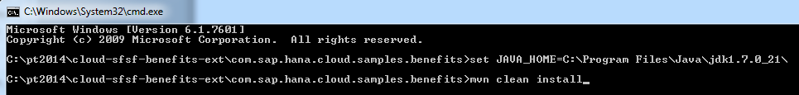

* + - 1. After a successful compilation, refresh your project. The com.sap.hana.cloud.samples.benefits.war file will be displayed under the target folder of your project in Eclipse :

c:\pt2014\cloud-sfsf-benefits-ext\cloud-sfsf-benefits-ext-master\com.sap.hana.cloud.samples.benefits\target

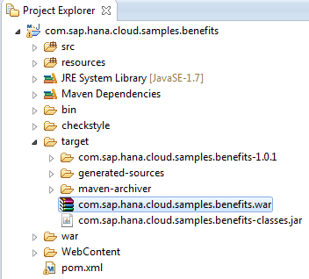

## Deploy the Corporate Benefits application to the HANA Cloud platform

In order to run the Corporate Benefits application, you need to deploy it to your SAP HANA Cloud extension package account.

Deploy the application from the console

* 1. Navigate to the tools folder in your SAP HANA Cloud SDK [c:\pt2014\neo-sdk-javaweb-1.42.19\tools\ ]
  2. Open a command line from that location.
  3. Run the following command to deploy the WAR to your SAP HANA Cloud extension package account:

**neo deploy --host** <host ID> **--account** <account ID> **--application** <target application name> --**source** <full path to the war file> **--user** <user ID> **--java-version 7**

For example:

neo deploy --host us1.hana.ondemand.com --account ae301b3ec --application benefits --user p1162192 --java-version 7 --source C:\pt2014\cloud-sfsf-benefits-ext\com.sap.hana.cloud.samples.benefits\target\com.sap.hana.cloud.samples.benefits.war

**TIP**: Copy the command to Notepad, replace the key fields with your specific data, and paste into the command line.

**NOTE:** Rather than entering the absolute path into the WAR file, copy it from its current location into the same Neo SDK tools folder from which you are running the command.

* 1. When prompted, enter the password related to your user (for user p1162192, password is Abcd1234)

|  |  |  |  |  |  |  |
| --- | --- | --- | --- | --- | --- | --- |
| **#** | **User ID** | **Password** | | **Account Alias** | **Account ID** | **CP URL** |
| **25** | **p1162192** | Abcd123 | pt025 | | ae301b3ec | <https://cloudptportal-ae301b3ec.us1.hana.ondemand.com/> portal/extensions/sfsf/index.html |

* 1. Wait for the success confirmation:

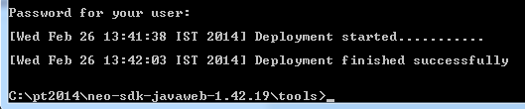

* 1. Now that the application is successfully deployed, you can see it in the cockpit of the SAP HANA Cloud Platform account:
     + 1. Navigate to: <https://account.us1.hana.ondemand.com/>
       2. Click *Log On* and enter the user name and password that were assigned to your  
          (for example: p1162192 / Abcd1234)
       3. Navigate to the *Java Applications* tab to view the Corporate Benefits application that you deployed.
       4. After deployment, the application is stopped. Press  to start it.

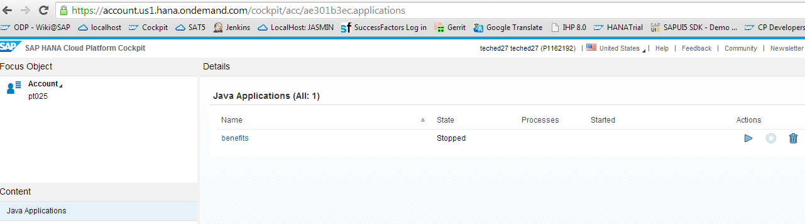

## Configure your application on the HANA Cloud platform

When setting up your extension account, we preconfigured a Trust between your account and the SuccessFactors Identity Providers (IDPs) enabling the applications deployed to your account to support login using the SuccessFactors user base.

As a result of this setup the login to the Cloud Portal space is done using SuccessFactors’ users credentials.

However, the login to the account cockpit is still done using the user credentials of the SAP ID IDP since that cockpit is not affected by the custom trust settings.

Configure the application role assignments

Now that the application is deployed and started, you can configure the application role assignments, which you do in the SAP HANA Cloud Platform Cockpit. As explained previously, the Corporate Benefits application supports two roles: **Administrator** and **Everyone**

In the SuccessFactors user base, the user Nancy Nash (user ID: nnnn) is the company’s HR manager and should therefore be assigned the Administrator role, as follows:

* 1. From the SAP HANA Cloud Cockpit, navigate to the *Authorizations* tab at the left.
  2. In the *Users* tab, search for Nancy Nash’s user ID nnnn and click *Show Assignments*
  3. *If no assignments are available,* ***the table appears empty****.*
  4. Click ***Assign*** button.

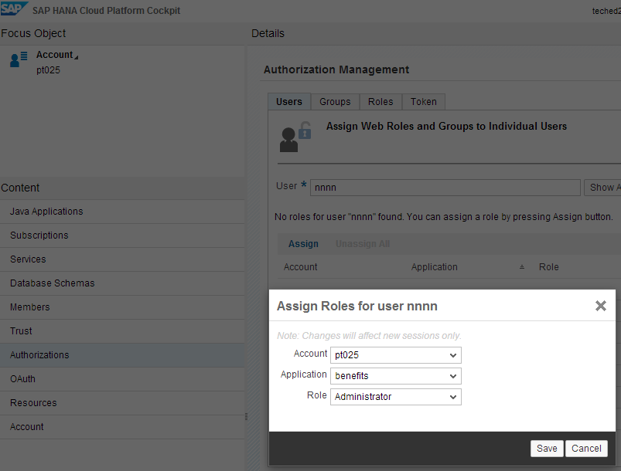

* 1. In the *Assign Roles* dialog box, enter the following details:
  + **Your** *Account* alias (for example pt025)
  + The name of the *Application* to which you are assigning the user with a role (benefits)
  + The desired *Role* (Administrator)
  1. Click *Save*.

**NOTE:**  By default, all other users are assigned the *Everyone* role, thus there is no need for further role assignment configuration

Configure application-to-application SSO

Now you can log on to the Cloud Portal space with the user credentials of your SuccessFactors IDP, and create a Cloud Portal site with a widget that runs the Corporate Benefits application. However, we want the user certificate from the initial logon to the Cloud Portal site to support SSO authentication to the Benefits application inside the site.

In order to achieve this, you need to configure application-to- application SSO authentication by creating and uploading a destination file to the subscription of your account for the Cloud Portal application.

* 1. Navigate to your SAP HANA Cloud SDK *tools* folder . [c:\pt2014\neo-sdk-javaweb-1.42.19\tools\ ].
  2. Open the *benefits* destination file in Notepad, and update the destination parameters as follows:
  + Name: benefits
  + Authentication: AppToAppSSO
  + Type: HTTP
  + ProxyType:Internet
  + URL: https://<application name><account alias>-<account alias>.us1.hana.ondemand.com/com.sap.hana.cloud.samples.benefits  
    For example:  
    <https://benefitsae301b3ec-ae301b3ec.us1.hana.ondemand.com/com.sap.hana.cloud.samples.benefits> )
  1. Save the file
  2. Upload the destination using the SAP HANA Cloud SDK tool:
     + 1. Navigate to your SAP HANA Cloud SDK tools folder
       2. Open a command line from that location, and run the following command to upload the destination:

neo put-destination --provider-account portal --provider-application pt -a <user account> --localpath <path to benefits destination file> -h us1.hana.ondemand.com -u <account user ID> -p <account user password>

For example:  
neo put-destination --provider-account portal --provider-application pt -a ae301b3ec --localpath benefits -h us1.hana.ondemand.com -u p1162192 -p Abcd1234

You will use the destination later when we create the open-social widget for your benefits application.

## Create a Cloud Portal widget

Now you can use the Corporate Benefits application in the SAP HANA Cloud Portal environment by creating an OpenSocial widget and later adding it to your site. Generally, Cloud Portal supports auto-discovery of deployed OpenSocial widgets; however, in this exercise ,you will create the widget manually.

* 1. Log on to your HANA Cloud Portal Extension.
     + 1. Navigate to https://cloudptportal-<account id>.us1.hana.ondemand.com   
          [For example: <https://cloudptportal-ae301b3ec.us1.hana.ondemand.com/> portal/extensions/sfsf/index.html ]
       2. Log on as the SuccessFactors IT administrator (admin / demo101).
  2. Click the *CONTENT* tab at the top of the screen.
  3. Click *Add Widget.*

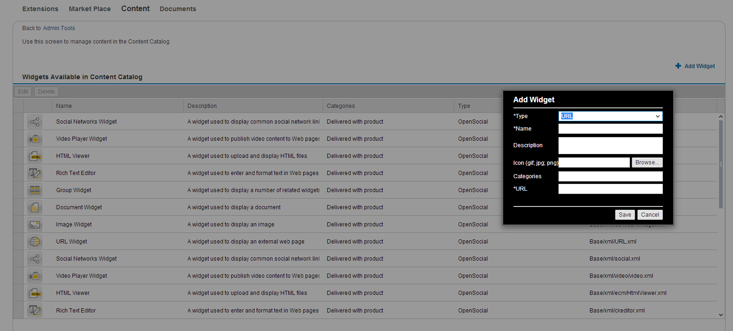

* 1. In the *Add Widget* dialog box, enter the following values:
  + *Type*: OpenSocial
  + *Name*: Benefits + <your account alias> (for example: Benefits pt25)
  + *URL*: The destination that you created and uploaded earlier to support the SSO between Cloud Portal and the application. The URL value should be in the following format: https://dest.<destination name>/spec.xml relative path in the application>  
    In this case: <https://dest.benefits/benefits.spec.xml>
  1. Click *Save*.

# Exercise 3: Creating and Integrating the COrPORATE BENEFITs Extension into SuccessFactors

In this exercise, you will integrate the Corporate Benefits application as an extension in the SuccessFactors BizX environment, to make it available to end users.

The SuccessFactors Extension landscape is set up by assigning **a single** **SuccessFactors tenant** to **a single** **Cloud Portal Extension account**.

To implement this exercise, we have provided multiple Cloud Portal Extension accounts to allow all participants to develop and deploy the Corporate Benefits application to their own accounts, used previously in this tutorial.

However, from this point on, you will use a single, **shared**, Cloud Portal Extension account. We have deployed the Corporate Benefits application to this account. You will use this application in the remaining exercises in this tutorial.

CAUTION: In order to ensure that you do not overwrite each other’s work in this shared account, please *carefully follow the instructions and the naming conventions.*

## Create the extension

Access the SuccessFactors environment

* 1. Navigate to SuccessFactors <https://salesdemo4.successfactors.com/login>.
  2. Log on as the company’s IT administrator:
     + 1. *Company ID*: SAPTECH03
       2. *User Name*: admin
       3. *Password*: demo101
  3. Check that you are on the *Administration Tools* page.

If not, from the  (Module Picker) menu, click *Admin Tools.*

Add an Extension to your *My Favorites* list

* 1. In the main content area, *Company Processes & Cycles,* click the *Company Settings* icon.

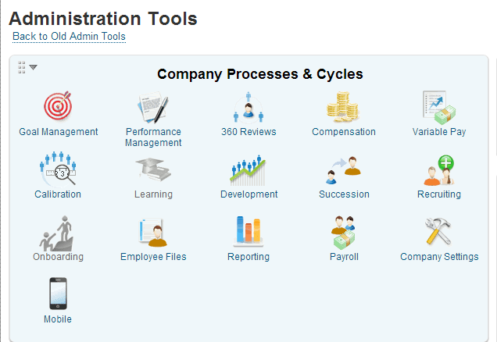

* 1. From the list of available options, hover over the Extensions entry, and click the  icon at the left.

A  is added to its left and a new *Extensions* entry is added to the *My Favorites* list.

Create a new extension

1. 1. Click *Extensions* from the *My Favorites* list at the right, to launch the Extension Management console.

**Note**: As mentioned previously, the Extension Management console is the Cloud Portal Extension ***shared account.***

* 1. Click **. The *New extension* dialog box opens.
  2. Give your extension a name following this convention: <username>-Corporate Benefits.

For example: p1162192-Corporate Benefits

**Remember! Be sure to follow the naming convention to avoid clashes with other trainees.**

* 1. Enter a description [optional]  
       
     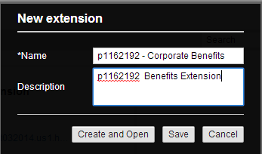
  2. Click *Create and Open*. Your new extension is opened in the Cloud Portal Authoring Space.

1. Add content to the extension

   2. From the side-panel menu, click  (Content Catalog). The Content Catalog opens.
   3. Search for the *Benefits* widget.

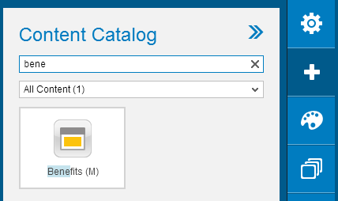

* 1. Double-click or drag-and-drop the *Corporate Benefits* widget to the page.
  2. Stretch and resize the widget so that it captures most of the page area.

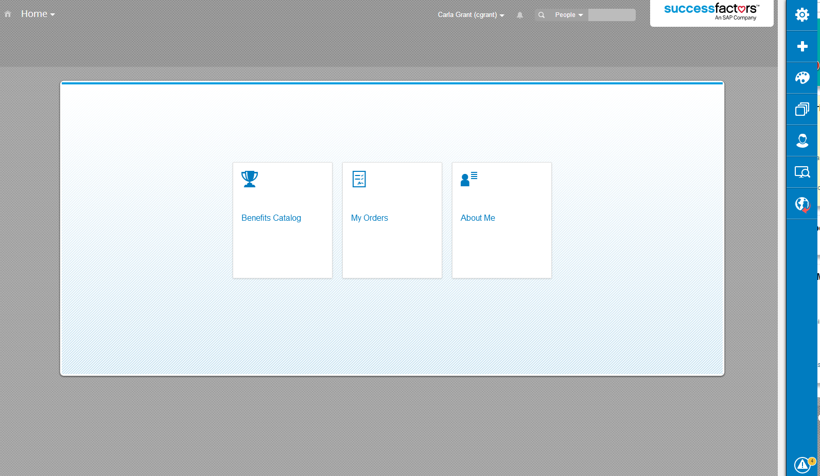

Set the Site and Page Access Level

* 1. From the side-panel menu, click  (Site Settings). The *Site Settings* panel opens.
  2. From the *Site Access Level* dropdown list, click *Restricted.* This indicates that only authenticated users can access your extension.
  3. From the side-panel menu, click  (Page Management). The *Page Management* panel opens.
  4. Hover over the page bar in the panel and click  (Page Settings). The page properties are displayed.
  5. From the *Access Level* dropdown list, click *Restricted*.

Hide the Page from the Page Navigation Bar

The Cloud Portal extension is a single-page site, which does not require a page navigation menu. In order to remove the menu, we need to remove the page from the page navigation bar.

* 1. Open the *Page Management* panel.
  2. Hover over the page bar in the panel, and click the  (Page Visibility*)* button. The icon changes to , indicating that the page is now hidden, and in our case, removing the page navigation bar.
  3. Ignore the error message at the bottom.

Edit the extension URL

* 1. Open the *Site Settings* panel again.
  2. Hover over the *Site URL,* and click it. The suffix area is activated for editing.
  3. Enter your user ID (such as p1162192)as the URL suffix.  
     This will enable you to identify the extension that you have created.

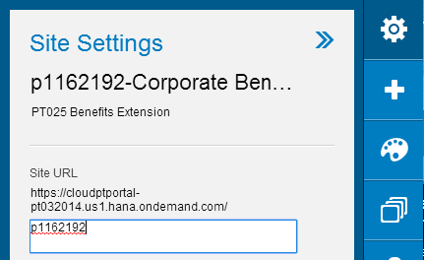

Publish the extension

* 1. From the side-panel menu, click  (Publishing Options). The *Publishing Options* panel opens.
  2. Click *Publish*, and in the *Publish Site* popup, click *Publish* again. A confirmation popup appears with a link to your published site.
  3. Click the link to your published site

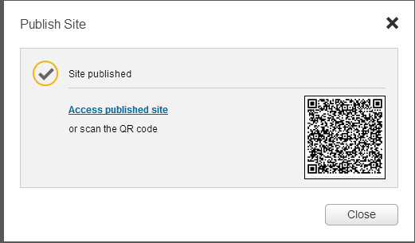

Your published extension opens in a new browser tab.

* 1. Copy the URL of your published extension and paste it into your Notepad for later use.   
     (For example: <https://cloudptportal-pt032014.us1.hana.ondemand.com/p1162192> ).

## Add an extension / application to SuccessFactors

**Add your extension to the Module Picker**

* 1. From the Extension Management console, click *Back to Admin Tools* to return to the *Administration Tools* page.

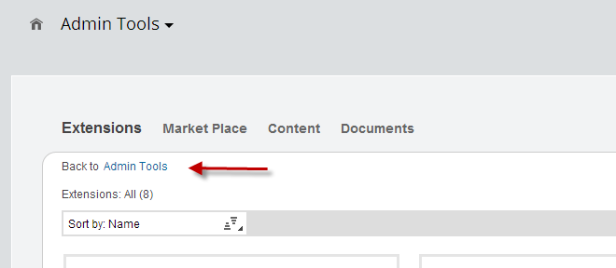

* 1. Click *Company Settings*> *Configure Custom Navigation.* The *Add Custom Menu* screen opens*.*
  2. At the bottom of the list, use the blank row to add a new menu item:
     + 1. In thefirst field, enter the application name according to our naming convention:

- <username>-Corporate Benefits

For example: p1162192-Corporate Benefits

* + - 1. From the *Link Type* dropdown list, select either *External Link – Same Browser or External Link – New Browser*.
      2. In the *URL* field, paste the application URL that you previously saved in your Notepad   
         ( For example: <https://cloudptportal-pt032014.us1.hana.ondemand.com/p1162192> )
      3. From the *menu Location* dropdown list,select *Top Navigation*.
  1. Click *Save* and refresh your browser.
  2. Open the Module Picker and verify that the new item has been added to the menu.

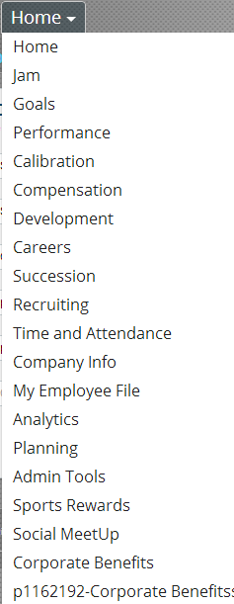

## Add a tile to the Home Page

Set up your tile

* 1. Go back to the *Administration Tools* page.
  2. In the *Tool Search* field at the top right, search for home page. This launches the *Manage Home Page* utility.
  3. Scroll to the bottom of the page, and click on the left.
  4. Under *Step 1* - *Tile Settings*, enter a *Tile Name* according to our convention:   
     <username>-Corporate Benefits. For example: p1162192-Corporate Benefits

(Leave the other parameters as is.)

* 1. Under *Step 2* – *Configure Content*, enter the following information:
  + *Tile Title*: same as the title used previously. For example: p1162192-Corporate Benefits
  + *Description*: Text that describes your extension

Add content to the tile

* 1. Still in *Step 2*, in the *Main Content* toolbar, click  (Add Image). The *Image Properties* dialog box opens.
     + 1. Right-click on this image, click *Save As Picture* and save the picture to your desktop:



* + - 1. Click the *Upload* tab, click *Choose File*, and upload the image that you just saved.

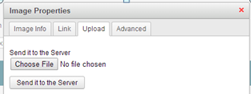

* + - 1. Click *Send it to the Server*.
      2. Click the *Link* tab and in the *URL* field, paste the URL of your extension, which you saved in Notepad.
      3. From the *Target* dropdown list, select *New Window (_blank)*.
      4. Click the *Image Info* tab and adapt the *Width* and *Height* of the image to fit the preview screen.
      5. Click *OK*.
  1. Add additional text using the text editor (optional).

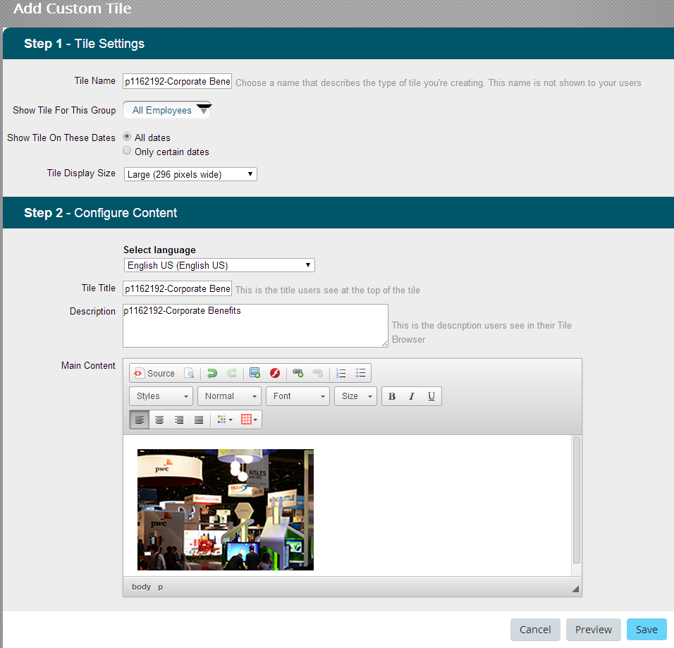

Preview and save the tile

* 1. At the bottom right of the *Add Custom Tile* screen, click *Preview.* You can click on the tile to open your Corporate Benefits extension.
  2. Click *Save* to save your created tile.
  3. From the Module Picker, return to the *Home* page. Now your extension is available both as a tile in the *Home* page and as a menu item in the Module Picker.

## 

## Customize a theme for the tile

Update the extension theme

* 1. Return to the *Administration Tools* page*.*
  2. Click *Company Settings*, and set the *Theme Manager* link as a favorite.
  3. Click *Theme Manager* and hover over the different theme names.
  4. Using the *Try it out* link (displayed when hovering), view the different themes.  
     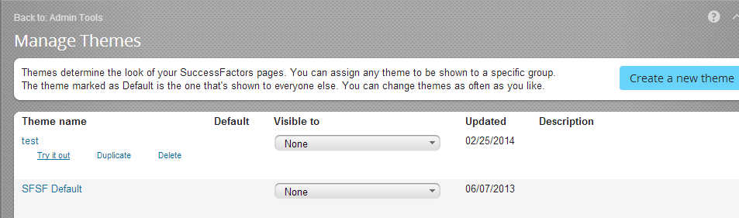
  5. From the dropdown list in the *Visible to* column of your favorite theme, select the groups who can see the theme.

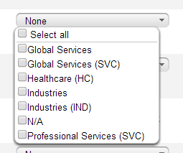

* 1. Click *Save* at the bottom of the screen to save the theme settings.

Creating a custom SuccessFactors theme

* 1. At the top of the screen, click *Create a new theme*.

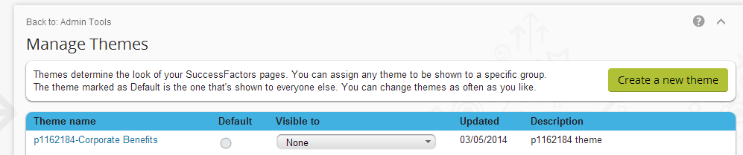

The Create a Theme editor opens. The left panel of the editor is used to create/adjust your custom theme. The right panel is a WYSIWYG page.

* 1. In the *Theme name* field, enter a name for your theme, following the same naming convention described previously: <user name>-**Corporate Benefits**.
  2. In the *Theme description* field, enter text about the theme.
  3. In the *Quick Theme* section, define any property for the theme, such as *Page background color*.
  4. In the *Fine Tune* section at the bottom of the panel, edit any other the parameters, such as the *Module Picker > Label text color*.
  5. When finished, click *Save* at the bottom of the panel to create your theme.
  6. Navigate back to the *Manage Themes* page, using the breadcrumbs.
  7. To make your theme visible to all groups, select the appropriate groups in the *Visible to* list (for our exercise, check *Select all*.

1. Applying the SuccessFactors theme to the Cloud Portal extension
   1. To apply the theme changes, first log out from SuccessFactors.   
      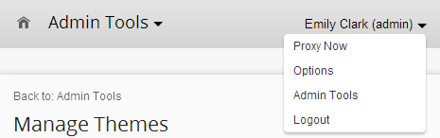
   2. Log back in as the IT administrator (admin / demo101). Your new theme is displayed.
   3. From the Module Picker, select your extension and confirm that the extension theme was updated with your new SuccessFactors theme.

# Exercise 4: Explore the corporate benefits extension

In this exercise, you will review the newly created extension. Now that you have added a new application to the SuccessFactors BizX environment, you can view it from both the end user and HR manager perspective. This should enable you to understand the business value of this extension and how it is consumed by each of the different business users.

The purpose of the SAP Corporate Benefits sample application is to facilitate the process of benefit management, both for employees and for HR managers. By default, the application has a hardcoded benefits list, and no campaigns are added. Employees should first log onto the application with their HR manager in order to add a benefits campaign.

## Employee role

Employees are rewarded with different non-monetary benefits, such as concert tickets and food vouchers. The application uses abstract “currency” – called “benefit points” – to evaluate the value of each benefit. In accordance with the company's policy, each employee is entitled to a particular amount of benefit points for a certain period of time. Each rewarding period is called a “campaign”, and is characterized by specific start and end dates, as well as a particular amount of benefit points.

Employees can edit their active campaign benefit orders, and view their past orders. They can also view a list of available benefits.

## HR manager role

HR managers are responsible for managing the campaigns and providing the employees with the rewards that they ordered for a particular campaign.

The HR managers manage benefits from the following panes:

* *Employees*

View all managed employees and details about each employee’s used and total benefit points for the current campaign. In addition, you can see order history of the employee for previous campaigns.

* *Benefits*

See a list and manage all available benefits in the benefits' portfolio.

* Campaigns

Add and edit benefits campaigns and their details.

* *Orders*

Edit your active campaign benefit orders and view your past orders

## Perform HR manager tasks

* 1. Log on to the SuccessFactors environment:
  + URL: <https://salesdemo4.successfactors.com/login?company=SAPTECH03>
  + *User Name*: nnash.
  + *Password*: demo101
  1. From the Module Picker, click *My* *Employee File*. The *My Employee File* screen opens.
  2. From the  dropdown list, select *Employment Information*.

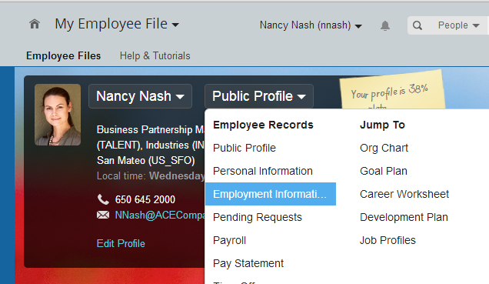

* 1. In the *Job Information* section of the *Job Information* list, confirm that Nancy’s *Job Classification* is *Human Resources Manager*.
  2. From the Module Picker, launch the *Corporate Benefits* application extension that you created.
  3. As HR manager you should see five tiles:

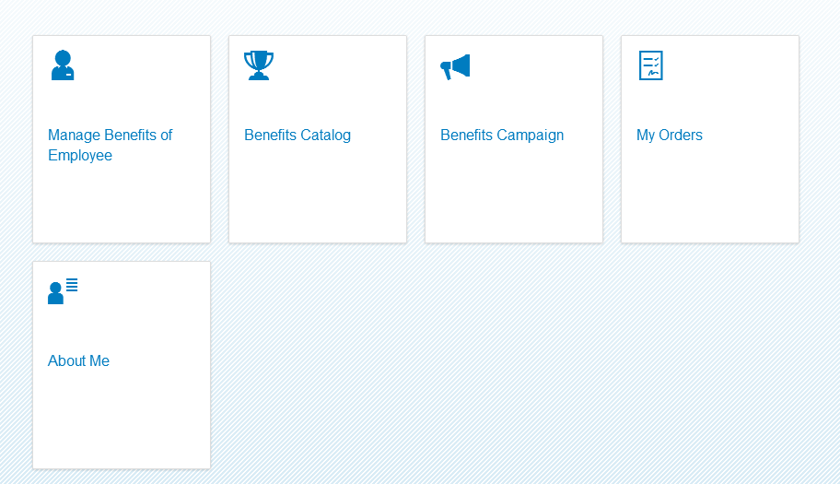

* + - 1. Open the *About Me* tile and explore the details retrieved from SuccessFactors.
      2. Click  to return to the *Corporate Benefits* application.
      3. Open the *Benefits Campaign* tile and click ** at the bottom to create a new campaign.
         1. Name it Summer Event<your ID>, and assign it 500 points.
         2. Click *Ok*. The screen is refreshed with your new campaign.
         3. Click your new campaign to highlight it, and then click  at the bottom right of the screen.
         4. Select a *Start Date* and *End Date*, and click *Ok*.
         5. Click *>>Start* to activate the campaign. (If a different campaign is *Active*, you may receive an error message).
      4. Click  to return to the *Corporate Benefits*.
      5. Open the *Manage Benefits of Employee* tile.
      6. Select the employee *Carla Grant.*
      7. Click  to add a new order for benefits on her behalf.
      8. Enter the order details and click *Ok*.
  1. Log out.

## Perform End User Tasks

* 1. Log in as Carla Grant (cgrant / demo101).
  2. From the Module Picker, select *Employee Files*.
  3. From the  dropdown list, select *Employment Information*.
  4. Scroll down, and in the *Job Relationships* section, confirm that Nancy Nash is Carla Grant’s HR manager.
  5. From the Module Picker, access your *Corporate Benefits* extension.
  6. Open the *About Me* tile and note that:
  + The details are shown for the logged on user: Carla Grant.
  + The HR Manager’s user details are also available here.
  1. Open the *Benefits Catalog* tile, and explore through it to see the list of available items.
  2. Open the *My Orders* tile, and check that the order previously created by Nancy Nash exists. Then add another order.